Ultrasoundx

Mobile private ultrasound shoulder scanning

Musculoskeletal Ultrasound Scans are an affordable, harmless and painless modality. The ultrasound generates real time images of muscles, tendons, ligaments, joints and cartilage.

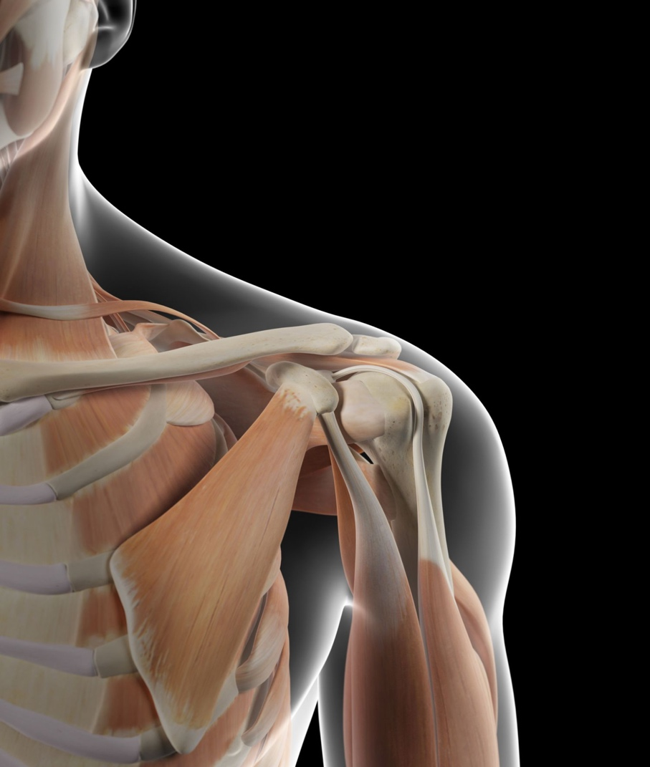
Shoulder Ultrasound scans can help identify a range of acute and chronic inflammatory or injuries related conditions such as tendonitis, bursitis, injuries, tendon tears, joint problems rotator cuff injuries. Impingement, frozen shoulder, or instability and masses such as tumours and cysts.

DYNAMIC FAST AND AFFORDABLE

What you get with Ultrasound X

Fully qualified and regulated professional.
Scan done at your home, place of work.
The highest possible image and data security
storage.
A diagnostic report within 24 hours
Friendly and supportive
Confidentiality
Cost for imaging 1 body part £150-00
Only for adults aged 18 years and over.
Patients who do not have capacity must have a referral from medical practitioner, no other referral is accepted.
No charge for cancellation, but we request you give 24 hours’ notice as good will.

Contraindications

Sports athlete, dementia or under
investigation for memory impairment.
We do not attend properties with pets present, and we do not attend high rise blocks.

For all female patients a chaperone must be present, or the scan will be declined.

Informed Consent Form for Diagnostic Ultrasound scanning of the Shoulder

You must provide

Clinical indication for the scan; injuries; previous investigations and treatments.

Details of previous investigations and scans?

Preparing for your scan.

Please wear clothing allowing exposure of affected shoulder from midline to skin edge. For all female patients a chaperone must be present. You may need to change into a gown for the procedure, which must be patients own.

The concept of informed consent is based on the principle that a doctor has a duty to disclose to a patient information which allows the patient to make a reasonable decision regarding their own management and treatment. There is no legal requirement that written patient consent be obtained prior to an ultrasound examination. However, it is good practice to ensure that patients are fully informed about the nature and conduct of the examination so that they can give verbal and /or written consent. It is desirable that this information is provided in written format, is given prior to their attendance and is reviewed by the person undertaking the scan at the time of attendance (1).

Risks

Ultrasound scanning does not involve X-rays and so does not have any of the risks associated with ionising radiation. Indeed, it has been shown to be one of the safest of medical techniques, and is used routinely to scan babies, both before and after birth, children and adults. It has been used to provide valuable pictures and other diagnostic information for four decades, with no evidence of any harm. Ultrasound gel is used as a coupling agent.
You will be asked to give permission for information from your examination to be shared with other healthcare professionals for referral purposes. Any information used in this way is only used by the healthcare professionals involved in your care.

In carrying out the ultrasound scan you will receive a verbal and copy of the report within 24 hours. Options of referral and further management will be discussed. The patient must self-refer. The patients body habitus affects penetration, depth, image resolution and tissue contrast.

I fully understand the details in this consent form and waive my right to any legal action against the individual or the company.
I fully understand and accept the terms mentioned above
I authorise the release of medical information necessary for further management to other healthcare professionals.
I am responsible for self-referral.

The patient should read the consent form and sign the form if they accept the terms.

I am not a sports athlete. I do not have metal work in the shoulder.

By booking for a scan, you agree with the principles outlined.
THE COMPANY CAN CANCEL IF REFERRAL FOR THE SCAN IS INAPPROPRIATE.

References

- The Safe Use of Ultrasound in medical Diagnosis. Ed G ter Haar & F Duck, The British Medical Ultrasound Society / The British Institute of Radiology, February 2000

